**COMP-CO710: Practice Web Page Test**

You will create one file called **camping.html**. The file is shown below in **Internet Explorer**:

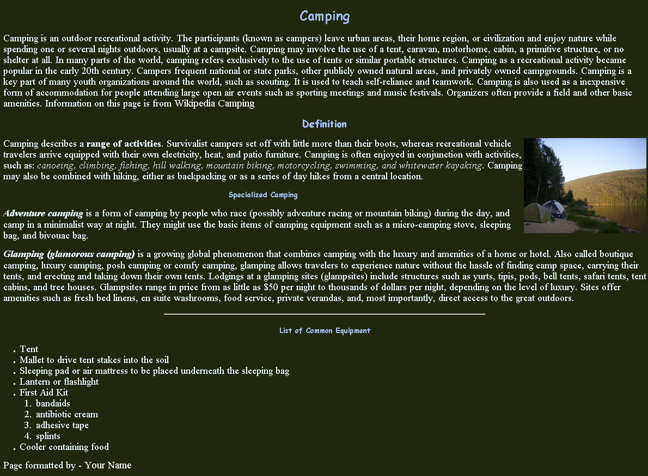

### Complete all of the following:

### General

* All HTML must be in lowercase
* All tags should conform to HTML5 standards, with closing tags where appropriate or be a self-closing tag where required
* HTML Tag Attributes all enclosed in " " (double quotes)
* The source file MUST contain DOCTYPE, html, head and body elements
* All CSS should be contained in the embedded stylesheet.

### Specific

* Comment at the top of the camping.html file with your name and student number
* The title for the page must be “Camping Information”
* The font for the body must be "Times New Roman", Times, serif
* The body text colour must be set to #e6f4ff.
* The body background colour must be set to #21270d.
* The size of the font in the body must be set to 1.5 times the normal size. Use the unit that represents the size of the letter ‘m’..
* Style the h1, h2 and h3 elements using a grouped selector such that the text is centered, coloured #a3bff1, and the font is "Comic Sans MS", cursive, sans-serif.
* Store the image in a folder called *images*. Display the image so it is:
  + right-justified
  + has a width of 300 pixels and a height of 233 pixels.
  + when the mouse hovers over the image, the popup text should display “Camping in B.C.”
* The Wikipedia article link at the end of the first paragraph must link to   
  [**http://en.wikipedia.org/wiki/Camping**](http://en.wikipedia.org/wiki/Camping) and when the mouse hovers over the link the popup text should display “Wikipedia Camping”
* Under the section **List of Common Equipment** the items must be displayed as shown in a nested list
* The email link at the bottom of the page must link to **your** Mohawk college e-mail address
* Horizontal lines, emphasis, strong, should be used as needed